Article Title in Title Case: Subtitles Optional

First Author¹, Second Author², Third Author^{1*}

¹First Author Affiliation,
Organization Address, City, Postcode, Country

²Second Author Affiliation,
Organization Address, City, Postcode, Country

*Corresponding Author

Abstract:
First sentence describes the nature or the background information on the field of study. Subsequent sentences provide the problem statement or objectives and scope of the research. Next sentences explain the methods and materials used in the work. Main results and important findings are then highlighted. Finally, a summary of conclusions is put forth. The length of abstract must not be more than 250 words.

Keywords: Keywords 1; Keywords 2; Keywords 3 to 8

Types of Submission

Authors should prepare their article, graphics and other materials according to the JMEDITEC guidelines as stated in the website. Research article must be an original research finding with introduction, materials and method, result, discussion and conclusion. Research article must be less than 10 pages and must generally satisfy the Guideline requirements for completeness.

Review article should be an original research with a coherent collection of methods, results, and conclusions from different publications on a particular topic with appropriate references to the original research. Review article can contain figures that have been published elsewhere with permission to reproduce or adapt for publication. Authors’ responsibility to obtain such permission from copyright holders before the article submission and forward it to the Editor-in-chief.

Manuscript Formatting and Article Template
Authors may refer to the this template for article preparation. The prepared article must be in MS Word and should be formatted for direct printing. Figures and tables should be embedded and not supplied separately. Special fonts, such as fonts used in the Far East (Japanese, Chinese, Korean, etc.) may cause problems during processing. To avoid unnecessary errors, you are strongly advised to use the ‘spellchecker’ function of MS Word. Follow this order when typing manuscripts: Title, Authors, Affiliations, Abstract, Keywords, Main text (including figures and tables), Acknowledgements, References, Appendix. Collate acknowledgements in a separate section at the end of the article and do not include them on the title page, as a footnote to the title or otherwise.

Tables
All tables should be numbered with Arabic numerals. Every table should have a caption. Headings should be placed above tables, left justified. Only horizontal lines should be used within a table, to distinguish the column headings from the body of the table, and immediately above and below the table. Tables must be embedded into the text and not supplied separately. Below is an example which the authors may find useful.
Table 1 - An example of a table
An example of a column heading | Column A (t) | Column B (t)
And an entry | 1 | 2
And another entry | 3 | 4
And another entry | 5 | 6

All figures should be prepared as in Figure 1. Most authors will be able to prepare images in one of the allowed formats listed above. No matter how you convert your images, it is a good idea to print the files to make sure nothing is lost in the process.

(a)
(b)
Figure 1. The figures can be divided into (a) on the left, (b) on the right

Construction of References
References must be listed at the end of the paper. Do not begin them on a new page unless this is absolutely necessary. Authors should ensure that every reference in the text appears in the list of references and vice versa. Indicate references by (Wang et al., 2013) or [(Chiarello et al., 2008; Wang et al., 2013) in the text.
Some examples of how your references should be listed are given at the end of this template in the ‘References’ section, which will allow you to assemble your reference list according to the correct format and font size.

Section Headings
Section headings should be left justified, bold, with the first letter capitalized and numbered consecutively, starting with the Introduction. Sub-section headings should also be in the same style as the headings, numbered 1.1, 1.2, etc, and left justified, with second and subsequent lines indented. Ensure the text area is not blank except for the last page.

Equations
Equations and formulae should be typed in Mathtype, and numbered consecutively with Arabic numerals in parentheses on the right hand side of the page (if referred to explicitly in the text). They should also be separated from the surrounding text by one space.
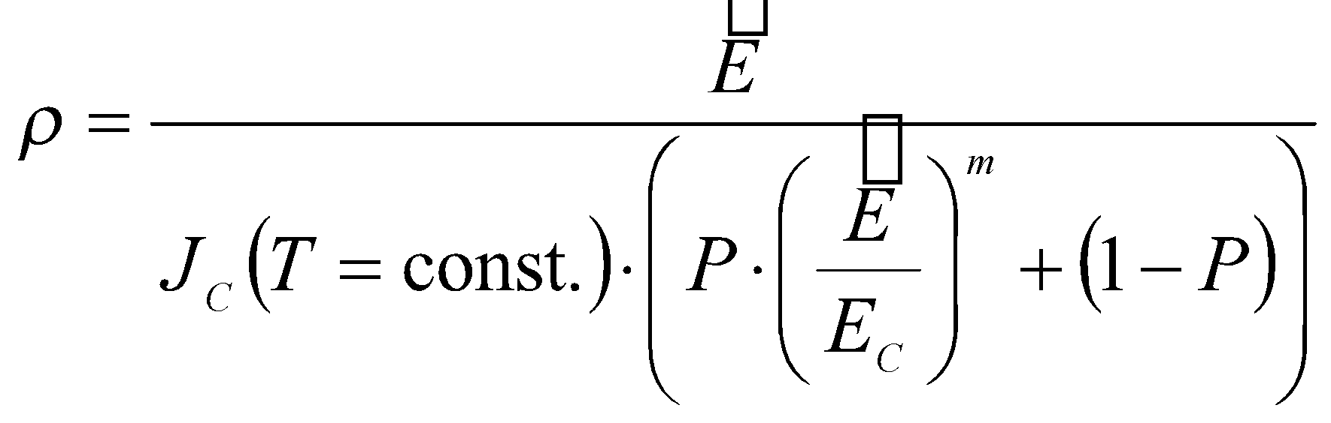 (1)
Acknowledgment

Acknowledgement and Reference heading should be left justified and bold with the first letter capitalized but have no numbers. Text below continues as normal.

References

Abbasi, N., Hamlet, S., M. Love, R., Nguyen, N. 2020. Porous scaffolds for bone regeneration. Journal of Science: Advanced Materials and Devices, 5(1),1-9.
Daish, C., Blanchard, R., Gulati, K., Losic, D., Findlay. D., Harvie, D.J., Pivonka, P. 2017. Estimation of anisotropic permeability in trabecular bone based on microCT imaging and pore-scale fluid dynamics simulations. Bone Reports 1(6), 129-139.
Dias, M. R., Fernandes, P. R., Guedes, J. M., Hollister, S. J. 2012. Permeability analysis of scaffolds for bone tissue engineering. Journal of Biomechanics 45(6), 938-944

